**MATLAB Codes:**

t=0:0.001:pi;

AC=10;

AM=10;

wc=90.*pi;

wm=30;

%%Defining Carrier Wave

xc=AC.*cos(wc.*t);

subplot(3,1,1);

plot(t,xc);

title ('Carrier Signal');

%%Defining Message Signal

xm= AM.*sin(wm.*t);

subplot(3,1,2);

plot(t,xm);

title ('Message Signal');

%%Final Output Wave

f=(xm.*cos(wc.*t))+xc;

subplot(3,1,3);

plot(t,f);

title ('Output when u=1');

A drawing of a face

Description generated with high confidence

t=0:0.001:pi;

AC=10;

AM=5;

wc=90.*pi;

wm=30;

%%Defining Carrier Wave

xc=AC.*cos(wc.*t);

subplot(3,1,1);

plot(t,xc);

title ('Carrier Signal');

%%Defining Message Signal

xm= AM.*sin(wm.*t);

subplot(3,1,2);

plot(t,xm);

title ('Message Signal');

%%Final Output Wave

f=(xm.*cos(wc.*t))+xc;

subplot(3,1,3);

plot(t,f);

title ('Output when u=0.5');

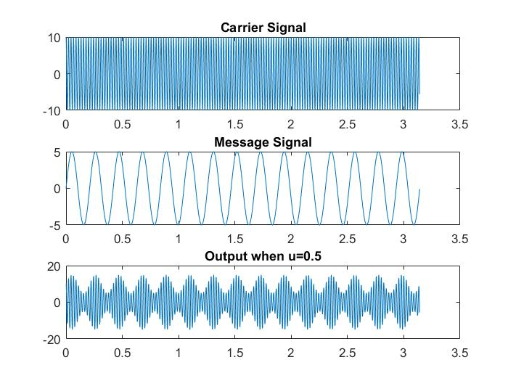

t=0:0.001:pi;

AC=10;

AM=20;

wc=90.*pi;

wm=30;

%%Defining Carrier Wave

xc=AC.*cos(wc.*t);

subplot(3,1,1);

plot(t,xc);

title ('Carrier Signal');

%%Defining Message Signal

xm= AM.*sin(wm.*t);

subplot(3,1,2);

plot(t,xm);

title ('Message Signal');

%%Final Output Wave

f=(xm.*cos(wc.*t))+xc;

subplot(3,1,3);

plot(t,f);

title ('Output when u>1');

A screenshot of a cell phone

Description generated with very high confidence

t=0:0.0005:0.2;

AC=1; AM=1;

wc=2000*pi;

wm=20*pi;

T=0.1;

%%Defining Carrier Wave

xc=AC.*cos(wc.*t);

subplot(4,1,1);

plot(t,xc);

title ('Carrier Signal');

%%Defining Message Signal

xm= AM.*sin(wm.*t);

subplot(4,1,2);

plot(t,xm);

title ('Message Signal');

%%Final Output Wave

f=(xm.*cos(wc.*t));

subplot(4,1,3);

plot(t,f);

title ('Output DSB-SC Signal');

%%Demodulation

VC(1)=0;

for i=2:length(f)

if f(i)>VC(i-1)

VC(i)=f(i);

else

VC(i)= VC(i-1)*(1-T);

end

end

subplot(4,1,4)

plot(t,VC);

title ('Demodulated Signal');

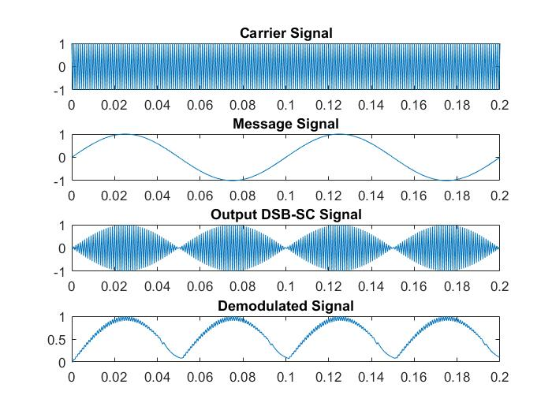

t=0:0.001:pi;

AC=10;

AM=5;

wc=20.*pi;

wm=3;

%%Defining Carrier Wave

xc=AC.*cos(wc.*t);

subplot(4,1,1);

plot(t,xc);

title ('Carrier Signal');

%%Defining Message Signal

xm= AM.*cos(wm.*t);

subplot(4,1,2);

plot(t,xm);

title ('Message Signal');

%%Final Output Wave

f=(AM.*AC*cos((wc+wm).*t))./2;

subplot(4,1,3);

plot(t,f);

title ('Output Upper Band SSB-SC Signal');

%%Demodulation

VC(1)=0;

for i=2:length(f)

if f(i)>VC(i-1)

VC(i)=f(i);

else

VC(i)= VC(i-1)*(1-T);

end

end

subplot(4,1,4)

plot(t,VC);

title ('Demodulated Signal');

A close up of measure

Description generated with high confidence

**Demodulation of AM**

fc=1000;

fs=2000;

t=0:0.0005:0.2;

AC=1;

msg=0.5;

m=0.5;

fm=20;

T=0.023;

w=2*pi;

%%Message Signal

xm= msg*cos(2*pi*fm*t);

subplot(4,1,1);

plot(t,xm);

title('Message Signal');

%%Carrier wave

xc= AC*cos(2*pi*fc*t);

subplot(4,1,2);

plot(t,xc);

title('Carrier Signal');

%%AM Wave

AM= cos(w*1000*t) + (0.25*cos(w*1020*t)) + (0.25*cos(w*980*t));

subplot(4,1,3)

plot(t,AM);

title ('AM Signal');

%%Demodulation

VC(1)=0;

for i=2:length(AM)

if AM(i)>VC(i-1)

VC(i)=AM(i);

else

VC(i)= VC(i-1)*(1-T);

end

end

subplot(4,1,4)

plot(t,VC);

title ('Demodulated Signal');

A close up of a piece of paper

Description generated with high confidence